Join the Daven Lore Wine Club!
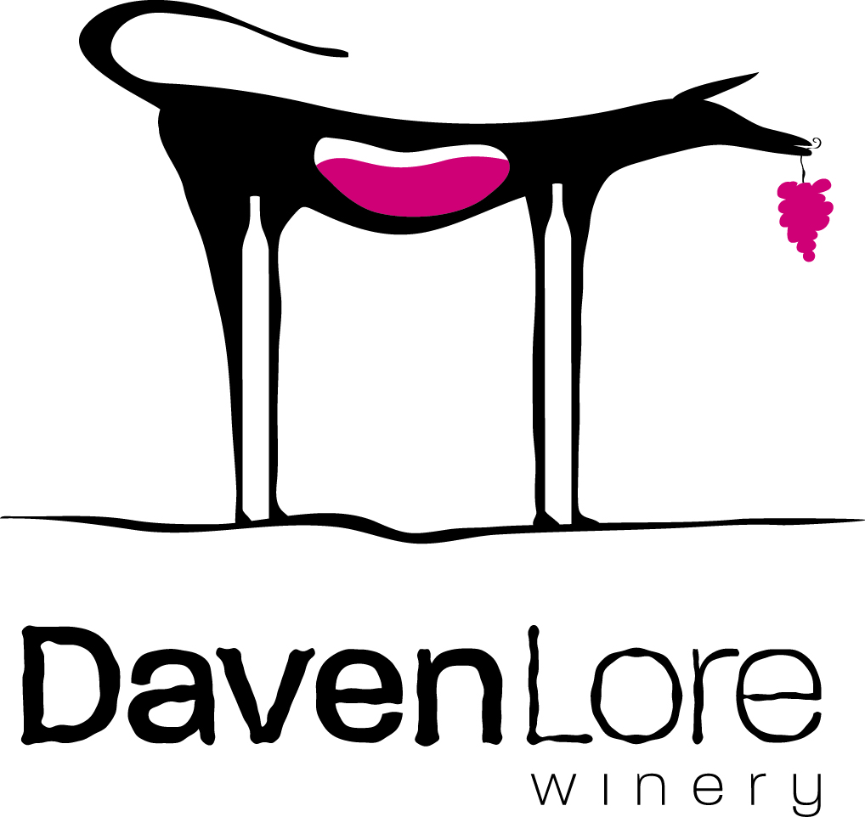

Ambassador Sampler Red Only SPRING FALL

Member Information
Name:
Address:
Start Date:
Email:
Phone: |  | Gift Membership?

Office Use: Shipping Instructions, Notes, preferences
Generally: Ship UPS Pick-Up Both Other(Bonnie’s) Gift □ TY □

Recurring Payment Authorization
I authorize DavenLore Winery to automatically bill the card listed below for wine club renewal membership fees of $_______ once annually in the Spring/Fall.
Beginning: _____/_____/______ and ending on: _____/_____/______.
Card Type: MasterCard Visa American Express Other_______________

Cardholder Name:_______________________Billing Zip Code: ________
Card number:____________________________ Expires: _____/_____
□ Notify me via email when my credit card is charged (make sure address above is correct)

______________________________ ________________________
Cardholder’s Signature Date

